Frequently Asked Questions

- How to access SCSTFMS application?
SCSTFMS application can be accessed by typing the URL as http://scstfms.cgg.gov.in in web browser. Usernames and Passwords are already communicated to the departments.

- How to use the application?
Login option is given in the SCSTFMS website. Login using your department login ID and password. On the top right-hand side there is help button. Click on it and you can download user manual.

- What is the email ID and contact number to report the issues?
Email ID is scstfms@cgg.gov.in and contact number is 8886132818 which scrolls on the SCSTFMS application
Issues can also be reported using “Post Query” option given in the application. Details mentioned at point FAQ 9.

- Where are the data uploading formats available?
In the Home page of the scstfms application, there is a tab named downloads. Please click on it and there is dropdown available. In dropdown select data uploading formats to view the formats. Select the suitable format based on the scheme categorization and benefit type.

- What Schemes are displayed in the SCSTFMS application?
Schemes which are having Minor Head of 789(SCSDF) & 796(STSDF) are taken from Budget portal and displayed for scheme categorization

- When and How to add a sub-scheme name?
- If the schemes are having sub-components for which the beneficiaries and benefits are different, then sub-schemes must be added.

- Please login using your department login ID and password. Go to services and select add sub-scheme.
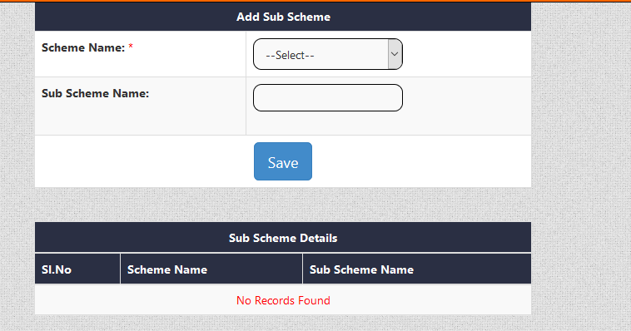
Add sub scheme
Select scheme name

- Where can we get master data for districts, mandals, villages, panchayats, and constituency?
Go to Homepage of SCSTFMS application and select downloads. From the drop-down select districts, mandals, villages.
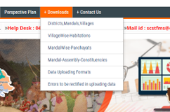

- How to upload beneficiary’s details?
Go to services and select beneficiary excel upload. Fill all the fields and upload the file. The master data such as Districts, Mandals should be as per the master data published in the website.

- How to fill data in beneficiary excel upload?
Follow the excel sheet on how to fill the beneficiary details.

- What is to be filled if Aadhar number is not available?

If Aadhar number is not available fill it as 0 and do not leave it as blank as the application do not accept blanks and NA for Aadhar number.
Aadhar number should be of 12 digits and spaces are not accepted in between.

- What to do if an error is hitting at date column?

Date should be entered in DD-MM-YYYY format. If data is not available give it as NA.

Please follow the below steps if an error is populating as problem in insertion:
- Mobile number should be 10 digits and if mobile number is not available give it as 0. Blank and NA is not accepted.
- If DD No. is not available give it as 0. Blank and NA is not accepted.
- If the data is not available for father name, enter as 'NA' but do not leave it blank. Special characters are not accepted.
- Upload the data in the format given in the web-site, do not change the format of uploading file.
- Gender should be given as M or F. Female and Male is not accepted.
- Caste should be given as SC or ST or ALL. Blank and – are not accepted.
- Bank Account number should be either 0 or the account number. Blank and – are not accepted.
- If IFSC code is not available give it as NA. Blanks and – are not accepted.
- Address doesn’t accept backward slash.
- Where can we view beneficiaries which we have uploaded recently?
Go to department reports and select beneficiary report. Select financial year and caste so that you can view the details of the beneficiary’s which you have uploaded.

- How to post a query?
Go to department login and select post queries. Fill up all the necessary information and post query.

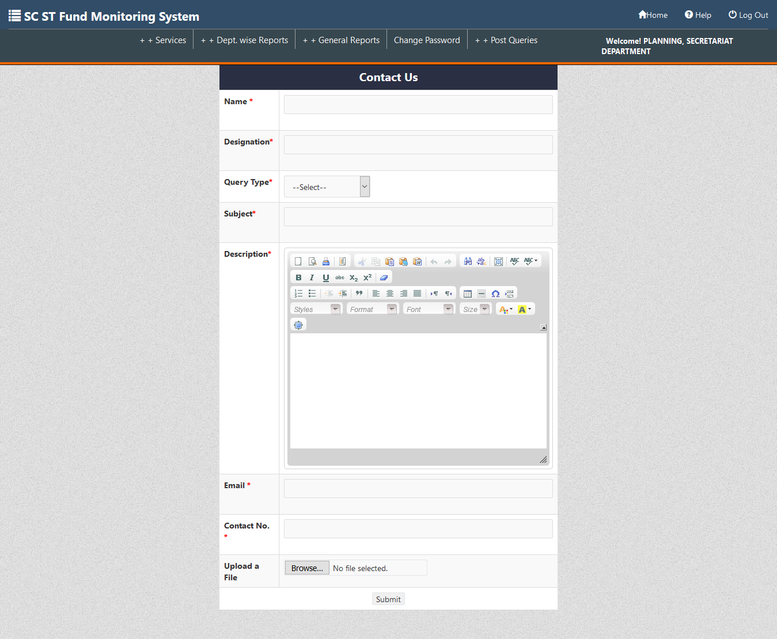

- How to change password?
Go to department login and click change password.
Change password service will enable the user to update the password. The user should enter the old password and enter the new desired password.
Note: Password should contain minimum 8 and maximum 10 characters with at least 1 Uppercase Alphabet, 1 Lowercase Alphabet, 1 Number and 1 Special Character.

